KORbuild

Daily — Overview
KORbuild product guide
Daily is the daily construction report (in Portuguese, RDO). Every workday, the subcontractor's person in charge on site records the weather, the crew, the equipment, the work performed, the issues and the photos. The general contractor of the job reviews and approves the report — or the subcontractor itself, on a job it has directly with the owner — and the approved report is sealed and shared with the client as a link or a PDF. See How KORbuild is organized.

Why it matters
- A record that holds up. When a client disputes a delay, the daily reports are the contractor's evidence: rain that stopped the pour, a late delivery, a missing inspection. Photos carry date, time and GPS inside the image, and the approved report is sealed.
- Reports that actually get done. Each job has a person responsible for its report, a daily deadline (6 PM) and reminders. The office sees the next morning which jobs did not report.
- Minutes, not an evening. On the phone, the foreman copies yesterday's report, adjusts the crew, dictates what was done and takes the photos. It works without signal.

Who uses it
Who | Where | What they do
Subcontractor's foreman | Phone | Fills out and submits the report of each job, every workday; fixes reports sent back.
General contractor (admin, project manager) | Computer | Follows every subcontractor on each job, reviews, approves or requests changes, shares with the owner. Does not fill out reports.
Subcontractor's office | Computer | Follows its own reports; approves them only on its jobs directly with an owner.
Client (owner or general contractor) | Any browser | Opens the link of the approved report, checks it is authentic and downloads the PDF. No account needed.
Who can do what depends on the access role: see Roles and permissions.

The main screens
Screen | Who sees it | What it shows
Today | Field | The jobs of the day, late reports, what is still missing today and requests for changes.
History | Field | Every report you filled out, newest first.
Report (editor) | Field | The report form: weather, crew, equipment, work performed, issues & delays, photos, notes.
Dashboard | Office | Numbers of the day, job status (green, yellow, red), jobs missing a report, approval queue.
Approvals | Office | Reports awaiting approval, reports sent back for changes, approved reports.
Jobs | Office | Every active job with its status; each job opens its reports and its schedule.
Client link | Client | The approved report, read-only, with the authenticity check and the PDF.
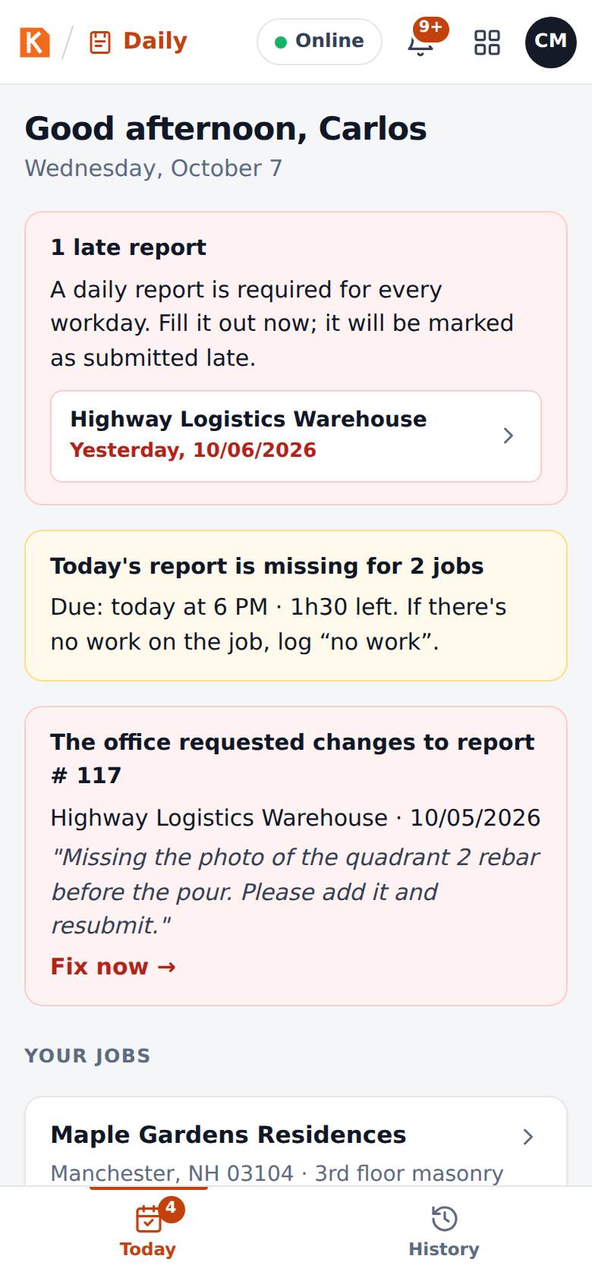
Today on the foreman's phone
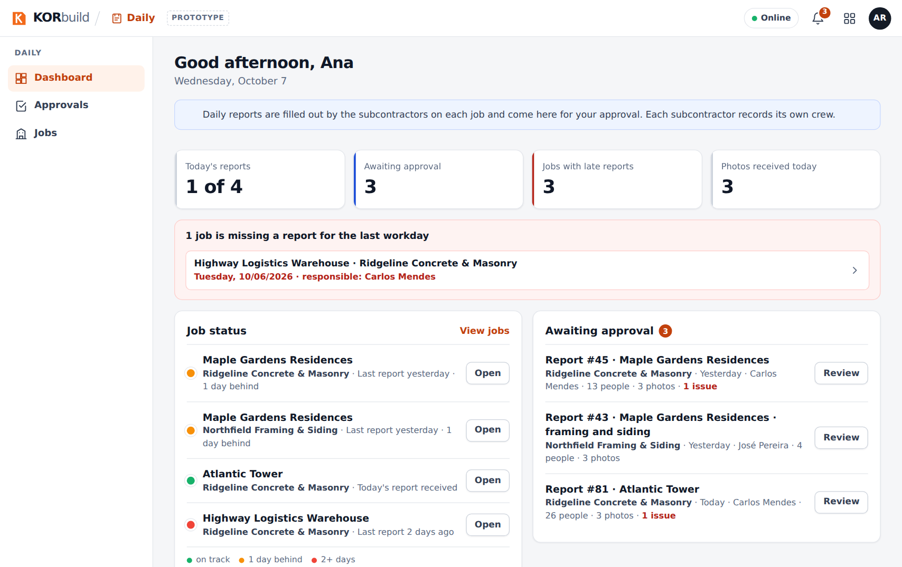
The office dashboard

How a report moves
Status | What it means | Who acts next
Draft | Being filled out; saved on the phone. | Field: submit.
Saved on this device | Submitted without signal; uploads by itself when the connection comes back. | Nobody: automatic.
Awaiting approval | Received by whoever approves it. | The general contractor (or the sub, on its own job): approve or request changes.
Changes requested | Sent back with a reason. | Field: fix and resubmit.
Approved | Sealed with a verification code. Nobody can change it. | Share with the client.
No work | The day was logged as "no work" with a reason (rain, holiday…). | Nobody.

Connected to the other modules
- Crew: when a report starts, the crew can be filled in from the people who clocked in on the job that day (Update from the crew that clocked in).
- Job schedule: each activity of the report can point to a task of the job's schedule with its % complete; when the report is approved, the schedule is updated.
- Jobs are set up once per company (Settings › Jobs). The general contractor registers its jobs; each subcontractor has its own job linked to the general contractor's, with who fills out the report and the workdays.

